|  |  |
| --- | --- |
| The challenge | Group 6  Luca Eremia (s2322684)  Stefan Grandia (s2587564)  Roel Brinkers (s2383225)  Arend Timmer (s2304236)  Jonne Hanning (s2393794) |

Table of contents

Introduction(Jonne) 2

Phase 1: Engage 2

Big idea (Arend) 2

Find essential questions 2

Define Challenges 3

Finding the best challenge 3

Phase 2: Investigate 3

Step 1: Guiding questions (Jonne) 3

Step 2: Activities and resources (Jonne) 3

Phase 3: Act 4

Conceptual model 4

Identify potential solutions 6

Next steps (Luca) 6

Planning: Gantt chart (Roel) 6

Rubric (self-assessment) (Stefan) 6

# Introduction

In this report we want to display our current progress. Figure 1 shows which specific steps we have to take in each phase, we are currently ending the investigation phase by summarizing the guiding questions in a report. The figure clearly shows the diverging and converging with in each phase.

Figure 1- Broad planning with the three phases

# Phase 1: Engage

The first phase of the CBL process has already been completed. This phase took roughly the first three weeks of this module. In this phase, the Big Idea and The Challenge were defined.

## Big idea

The Bid Idea was defined as ‘Water Nuisance’. The Big Idea was based on the fact that the majority of our project does the water track of the CEM master. Additionally, everyone found the topic interesting. Especially since this problem is in the news a lot lately. Look for instance at Enschede this summer, or East Europa in September, or right now the storm in Florida.

## Find essential questions

Based on the Big Idea, the group came up with essential questions regarding this Big Idea. Each question took into account the tips from the lecture, on how to formulate a good question. The seven essential questions were defined by the group:

1. How do CE companies actually contribute to achieving sustainability?
2. **How are people aware of CC impacts on water nuisance?**
3. How resilient are the Dutch for CC?
4. **What additional impact does CC has on extreme weather conditions?**
5. What are noticeable consequences of CC on citizens?
6. How can we ensure good water quality for the future, with respect to climate change?
7. **How can society prepare itself for CC, with respect to water?**

From these seven questions, the three most important questions were determined, these are displayed in **bold.** These three questions were found the most interesting by the group, therefore they were selected for defining the Challenge.

## Define Challenges

The three selected questions were transformed into a challenge. Provided that the challenges are phrased as actions, have an impact on society and that it engages the group’s interests. At last, the Challenge should be feasible in this module’s time frame. From the three questions, the following three Challenges were formulated:

1. Make CC impact on water nuisance better understandable.
2. Get a better grasp on extreme weather conditions and it's relation with Climate Change.
3. Make society more resilient for increased water nuisance.

## Finding the best challenge

From these three challenges, further discussion arose, which one we should choose. Finally we settled with the third challenge, since this challenge generally fitted our career ideas and interests the best. Hence the challenge for our group is going to be:

***“Make society more resilient for increased water nuisance.”***

# Phase 2: Investigate

## Step 1: Guiding questions

**Challenge: Advising on how the Haaksbergerstraat in Enschede can be more resilient against rainwater nuisance.**

Question 1: What is the capacity of the sewage system of the Haaksbergerstraat?

Question 2: How much of the area is paved?

Question 3: How much water is coming into the Haaksbergerstraat from other neighborhoods?

Question 4: What is the capacity of the current storage facilities?

Question 5: What are the current measures that were taken when the area was flooded and what is the Municipalities water nuisance policy?

Question 6: What is the recurrence time of heavy precipitation events that result in flooding?

Question 7: What were the damages of the water nuisance in 2024?

Question 8: What type of sewage system is present in the Haaksbergerstraat?

Question 9: Are there any green roofs in the street?

Question 10: Which department at the municipality is responsible for water nuisance?

Question 11: Which location experiences the most water nuisance?

Question 12: How is the impact of the study going to be measured?

Question 13: Are there subsidies available for residents that want to improve the resilience of their house to water nuisance?

Question 14: How are people currently motivated to convert paved gardens into green gardens?

Question 15: Why is there, currently, a limited amount of houses with green gardens?

## Step 2: Activities and resources

We made a division of tasks, together with the activities and resources needed. Important to note is that the planning is currently for the people themselves but we want to change this by a more integral approach.

|  |  |  |  |  |  |  |
| --- | --- | --- | --- | --- | --- | --- |
| Interview municipality | | | | | | |
| What is the capacity of the sewage system of the Haaksbergerstraat? | | | | | | |
| **Guiding activities** | | | **Guiding resources** | | **Plan (time/when)** | **Who** |
| Search online Info. | | | Open-source doc. | |  | Roel&Jonne |
| Interview municipality (There is no time at the municipality to help is so we switch to residents) | | | Interview template | |  | Roel&Jonne |
| The capacity of the sewage system is prone to change due to silting up of the sewage pipe, the capacity also varies significantly within a neighborhood. Therefor we choose to use the design discharge as measure for the actual discharge. The discharge is expressed in mm/ hour and given as a policy guideline of 20 mm/hour (Meyer, 2024) | | | | | | |
|  | | | | | | |
| What is the capacity of the current storage facilities? | | | | | | |
| **Guiding activities** | | | **Guiding resources** | | **Plan (time/when)** | **Who** |
| Interview municipality | | | Interview template | |  | Roel&Jonne |
| The sewage system in Enschede is a little more than 100 years old. Small springs were removed and a mixed sewage system together with above and underground storage was placed. Neither above nor underground storage facilities are present in the project area. It should be mentioned that there is also little space available. (Gemeente Enschede, RHDHV, 2022) | | | | | | |
| What were the implications of the water nuisance in 2024? | | | | | | |
| **Guiding activities** | | | **Guiding resources** | | **Plan (time/when)** | **Who** |
| Search online | | | Online articles | |  | Roel&Jonne |
| Interview resident | | |  | |  | Roel&Jonne |
| ANTWOORDEN VAN BRAM NOG HIERBIJ.  Due to the heavy precipitation event 79 houses became uninhabitable. The main cause was the rotting of foundations caused by water flowing into the houses. The total damage is in the order of millions which should be accounted for by the residents, the housing corporations and the municipality. In addition, all traffic was not able to cross for several hours. This formed mayor traffic problems because it involved the ring road of Enschede. (Tubantia, 2024) (Oost, 2024) | | | | | | |
| What are the current measures that were taken when the area was flooded and what is the Municipalities water nuisance policy? | | | | | | |
| **Guiding activities** | | | **Guiding resources** | | **Plan (time/when)** | **Who** |
|  | | |  | |  | Stefan |
|  | | | | | | |
| What type of sewage system is present in the Haaksbergerstraat? | | | | | | |
| **Guiding activities** | | | **Guiding resources** | | **Plan (time/when)** | **Who** |
| Interview municipality | | | <https://www.1twente.nl/artikel/4558692/op-enschede-viel-binnen-het-uur-honderd-millimeter-water-daar-kan-geen-rioolsysteem-tegen-op> | |  | Roel&Jonne |
| The sewage has a capacity of 20mm in most places. In some places, like the Oldenzaasestraat there is a capacity of 40-50 mm. However, this is not the case for our study area. | | | | | | |
| Which department at the municipality is responsible for water nuisance? | | | | | | |
| **Guiding activities** | | | **Guiding resources** | | **Plan (time/when)** | **Who** |
| Using university network | | |  |  | Roel&Jonne |
| There is a department within the municipality which is responsible for water and climate adaptation. This includes the daily management of the sewage system as well as long-term plans. These long-term plans include blue green grids as prevention of water nuisance. | | | | | | |
| How are people currently motivated to convert paved gardens into green gardens? | | | | | | |
| **Guiding activities** | | | **Guiding resources** | | **Plan (time\when)** | **Who** |
|  | | | https://steenbreek.nl/wp-content/uploads/2021/03/ACT-rapport-Steenverdween-inclusief-disclaimer-en-copyright.pdf | | now | Stefan |
|  | | | | | | |
| Neighbourhood characteristics | | | | | | |
| What percentage of the area is paved and what is greenery? | | | | | | |
| **Guiding activities** | | | **Guiding resources** | | **Plan (time/when)** | **Who** |
| Analyze Google map | | | Google Maps | |  | Jonne |
| Interview municipality | | | Interview template | |  |  |
|  | | | | | | |
| Are there any green roofs in the street? | | | | | | |
| **Guiding activities** | | | **Guiding resources** | | **Plan (time/when)** | **Who** |
| Visual check | | | Google maps/field work | | 23-10 | Stefan |
| There are no green roofs in the study area | | | | | | |
| Which location experiences the most water nuisance? | | | | | | |
| **Guiding activities** | | | **Guiding resources** | | **Plan (time/when)** | **Who** |
| Check maps&articles | | |  | |  | Luca |
|  | | | | | | |
| Water parameters | | | | | | |
| What is the recurrence time of heavy precipitation events that result in flooding? | | | | | | |
| Guiding activities | | | **Guiding resources** | | **Plan (time/when)** | **Who** |
| Search Online | | | Online articles (Beersma, Hakvoort, Jilderda, Overeem, & Versteeg, 2019) | |  | Stefan |
| Calculations | | | Recurrence time | |  |  |
|  | | | | | | |
| How much water is coming into the Haaksbergerstraat from other neighborhoods? | | | | | | |
| **Guiding activities** | | | **Guiding resources** | | **Plan (time/when)** | **Who** |
|  | | |  | |  |  |
| What is the infiltration and storage capacity of green roof? | | | | | | |
| **Guiding activities** | **Guiding resources** | **Plan (time/when)** | **Who** | |
| Search online | | | Acticles | |  | Arend |
| What is the infiltration and storage capacity of unpaved areas? | | | | | | |
| **Guiding activities** | | | **Guiding resources** | | **Plan (time/when)** | **Who** |
| Search online | | | **Articles** | |  | Arend |

# Phase 3: Act

Currently, we are still partially in Phase 2 while also beginning work on Phase 3. As a result, this section will elaborate on the progress made in this phase so far, though it is not yet complete.

## Conceptual model

The goal of this challenge is to enhance society's resilience against water nuisance by understanding how to make a neighborhood more resilient. To achieve this, a hydrological model representing a residential area will be developed. This model will be coded in Python using the Spyder IDE. The hydrological processes used in the model are based on prior coursework (Hydrology, Hydrological Modeling & Forecasting) and additional research.

A basic hydrological bucket model is used, incorporating all significant hydrological flows and parameters, including precipitation, soil infiltration, storage capacity, runoff from other regions, and discharge through the sewage system. Figure 1 shows a schematic representation of the model.

The model operates iteratively over time. Initial inputs include cumulative precipitation and discharge from adjacent areas, with the required output being the water level remaining in the study area. All hydrological components are straightforward to implement, except the Curve Number (CN) method, which requires additional elaboration.

The CN method represents the infiltration component. It is widely used to estimate direct runoff or rainfall excess by considering land use, soil type, and hydrologic conditions. Different neighborhood land uses can be modeled by assigning appropriate CN values.

The runoff equation for the CN method is given by:

$$Q =\frac{{\left(P - I_{a}\right)}^{2}}{\left(P - I_{a} + S\right)} for P > I_{a}$$

* Where:  
   - Q = runoff (in mm),  
   - P = total rainfall (in mm),  
   - Ia = 0.2S,  
   - S = 1000 / CN - 10 (in mm).  
   - CN = value from a table based on land use, soil type and hydrologic condition

Rainfall excess represents the water depth that remains on the surface and does not infiltrate. By multiplying by area, volume can be determined.

Using this volume, different hydrological components can be added or subtracted as shown in Figure 1. The total remaining volume is divided by the area to calculate the resulting water depth (hw). Adjusting parameters or adding components helps identify potential solutions to reduce the water depth in the neighborhood.

Figure 2 - Conceptual model

## Impact Indicators

# Next steps

Our next steps include finishing up with Investigation Phase and starting the Act Phase. Our plan is to prioritize practical, individual-level solutions to enhance resilience against heavy rainfall, as we see this approach as the most effective way to drive meaningful change. We are currently finalizing identifying the key issues, such as excessive paved areas and poor garden drainage, that contribute to flooding in Haaksbergerstraat. Once these issues are clearly defined, we will brainstorm feasible and accessible solutions that residents can easily adopt. Our outreach strategy will feature posters displayed throughout the neighborhood, each with a QR code linking to a short, engaging video that explains the flood risks, presents potential solutions, and inspires community involvement. By actively engaging the community and encouraging individual action, we aim to foster a shared sense of responsibility and create a stronger, more resilient neighborhood.

## Planning: Gantt chart

The upcoming weeks will be essential and still a lot of works needs to be done. For this reason, it was chosen to create a Gantt chart of the last 5 weeks including some main tasks and the deadlines. In this Gantt chart the start and end dates of each task, along with their progress are visualized. This helps us maintain focus and ensure that we are on track with our deadlines. Ultimately, the Gantt chart serves as a guide for working in an organized manner, helping us achieve our goals efficiently and minimizing delays.

Seen from the Gantt chart, we are currently slightly behind on some tasks, particularly in gathering information. This will be our focus for the upcoming week(s) since this part is essential for the content of the model.

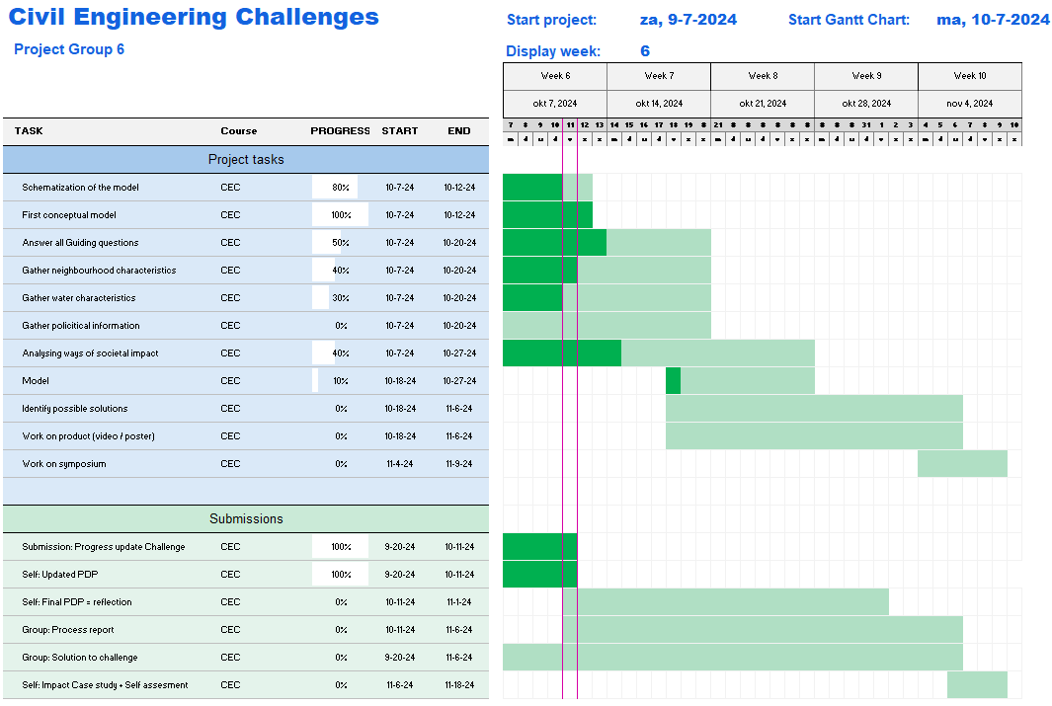

# Rubric (self-assessment)

**Single-point Rubric for the Solution to the Challenge**

|  |  |  |  |
| --- | --- | --- | --- |
| **Not Yet** (areas that need work) | **Proficient**  (performance standards) | **Evidence** (how you’ve met standards) | **Advanced** (areas that go beyond the basics) |
|  | **Big Idea and Challenge Selection**  Generates essential questions related to the Big Idea (sustainability/circularity) and from that identifies a creative, focused, and manageable Challenge (critical reflection on scoping, resources and feasibility) that addresses potentially significant, yet previously less-explored aspects of the Big Idea. |  |  |
|  | **Design process**  All elements of the CBL methodology or other theoretical framework (approved by lecturer) are skillfully developed. Appropriate methodology or theoretical frameworks may be synthesized from across disciplines or from relevant subdisciplines (provided approval by the lecturer). |  |  |
|  | **Knowledge, Research, and/or views**  Regarding existing knowledge: gathers, investigates and synthesises in-depth information from relevant sources representing various points of view/approaches/perspectives to the Challenge. Regarding new knowledge and innovation: organizes and synthesizes evidence to reveal insightful patterns, differences, or similarities related to the Challenge. |  |  |
|  | **Data accessibility, storage and repository**  Information, knowledge and intermediate products are stored in a repository that meets Data Management and Privacy regulations. The repository is publicly available, or can be made available to individuals on request. |  |  |
|  | **Identify potential solutions**  Identifies multiple potential solutions for contributing to the Challenge that apply within a specific context. Solutions indicate a deep comprehension of the Challenge. Solutions are sensitive to contextual factors as well as all of the following: ethical, logical, and cultural dimensions of the Challenge. |  |  |
|  | **Evaluate potential solutions**  Evaluation of solutions is deep and elegant (for example, contains thorough and insightful explanation) and includes, deeply and thoroughly, all of the following: considers history of previous solutions to the Challenge, reviews logic/reasoning, examines feasibility of solution, and weighs impacts of solution. |  |  |
|  | **Implement solution**  Implements the solution in a manner that addresses thoroughly and deeply multiple contextual factors of the Challenge. |  |  |
|  | **Basic requirements**  Writing is clear, effective and insightful. Free of spelling or grammar mistakes. Transitions tie sections together, as well as adjacent paragraphs. Paragraphs are well structured and focused. Smooth flow and effective transitions within paragraphs. If tables and figures are used, they are explained and referred to in an appropriate way. The APA format for referencing is used accurately and consistently. All needed citations are included in the paper. The reference list matches the in-text citations, and are all encoded in APA format. The report includes a title page and informative headings and subheadings in all parts. It is indicated if and how AI (e.g. ChatGPT) is used. |  |  |
|  | **Pass/fail rules**  To pass this assignment, you need to score proficient on all performance standards. Areas that need work (left column) can be compensated with areas that go beyond the basics (right column). However, no more than 2 areas may be compensated. |  |  |
|  | **Video presentation and engagement** The video engages the audience through clear and confident presentation. Visuals and audio are effective in enhancing the viewers experience and understanding of the topic. |  |  |
|  | **Video quality** The video is put together well. The video quality high resolution and the audio is clear. The transitions in the video are smooth and the shots are set up well. |  |  |
|  | **Model quality**  The model that is made is accurate. The chosen model setup is fitting for the use-case and the chosen parameter values are appropriate and substantiated. Any assumptions or simplifications that are made are clearly substantiated and logical. |  |  |

“During the preparation of this work the author(s) used Grammarly in order to improve the writing of this report. After using this tool/service, the author(s) reviewed and edited the content as needed and take(s) full responsibility for the content of the work.”

References:  
<https://www.oost.nl/nieuws/2459575/woningcorporatie-alles-in-het-werk-gesteld-voor-gedupeerden-van-noodweer-in-enschede-schade-in-de-miljoenen>

<https://www.tubantia.nl/enschede/enschede-komt-met-compensatie-voor-waterschade-zware-wissel-op-getroffen-mensen~a50bdd2b4/?referrer=https%3A%2F%2Fwww.google.com%2F>

<https://groenblauwenschede.ireporting.nl/FbContent.ashx/pub_1001/downloads/v210622195815/Water-%20en_klimaatadaptatieplan%20Gemeente%20Enschede%202022-2026.pdf>

<https://www.klimaateffectatlas.nl/nl/basiskaart-groen-en-grijs>